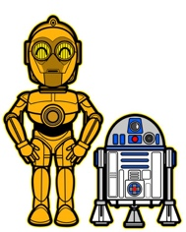
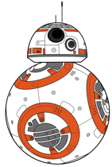
A Rotation Station Review

Station 1: 8.5A – Structure of Atom
- Using models, identify each element.
  - ________________
  - ________________
  - ________________
  - ________________

- Identify each particle on the model.

 | Particle | Charge | Mass
A
B
C
D

- Using the cards, identify the mass of each element and the charge of the nucleus.
 | Mass | Charge of Nucleus
1.
2.
3.
4

Station 2: 8.5B – Identity/Reactivity

- Using the Bohr Model Cards in the bag & PTE, list the names of the elements from most reactive to least reactive.
_______________ _______________ _______________ _______________
- Using the PTE, identify the number of protons for following elements.
Ne: ____ He: ____ Cl: ____ C: ____ Li: ____
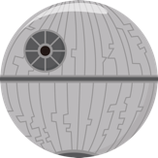
- Using the Green Element cards, answer the following questions:
  - Which two elements have the same reactivity? ___________ & ____________.
  - What characteristics of an element determines which other elements they will react with? ______________________________________________________.
______________________________________________________________________________

Station 3: 8.5C – PTE Groups/Periods

- Using the elements & Period Table of the Elements.
  - Which two elements are in the same group? _____________ & ______________
  - Which two elements have similar chemical properties? _________ &__________
  - How do you know that they have similar chemical Properties? __________________________________________________________________
  - Which elements are in the same group? ______________ & _______________
  - Which two elements are in the same period? _____________ & _____________
Station 4: 8.5D – Chemical Formulas

- Using the chemical formula models.
Pink=Sodium Black=Oxygen Green=Hydrogen Red=Carbon Blue=Chlorine

Write in the formula: A. ___________ B. _____________ C. ______________
- Using the chemical formula cards, count how many atoms are present for the specific element.
  - Carbon ____ b. Sodium ____ c. Calcium ____ d. Nitrogen ____
______________________________________________________________________________

Station 5: 8.5E – Evidences of Chemical Change

- Using O C G L T P, write the evidence for each picture.
  - __________________ c. ___________________
  - __________________ d. ___________________
- identify each statement on the card as a physical change or a chemical change.
  - __________________ d. ___________________
  - __________________ e. ___________________
  - __________________ f. ___________________
______________________________________________________________________________
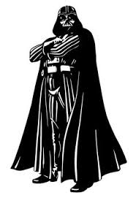
Station 6: 8.5F – Balancing Equations

- Identify the part of an equation by placing the cards in the correct order.

- Using the chemical equation that is on the strip of paper,
  - How many atoms are on both sides? _________ _________
  - Is the equation balanced? ______________
  - Which 3 coefficients balance the equation? ____ ____ ____
______________________________________________________________________________

Station 7: 7.6A – Organic Compounds

- Using the chemical formula cards, list the following:

Organic Compounds | Inorganic Compounds

Which Element must be present in all organic compounds? _______________________

Station 8: 7.6B – Physical/Chemical Changes in Digestion

- Using the picture identify which represent chemical changes and which ones are physical changes.
  - _________________ d. _________________
  - _________________ e. _________________
  - _________________ f. _________________
______________________________________________________________________________

Station 9: 6.5C – Elements/Compounds

- Using the strip of chemical formulas.

Elements | Compounds

Station 10: 6.6A – M/MET/NM

- Using the cut outs and the PTE, sort the characteristics into the right categories & write them down.

Metals | Metalloids | Non-Metals

READY YOU ARE
CHEMISTRY YOU HAVE MASTERED

