**Matter & Energy**

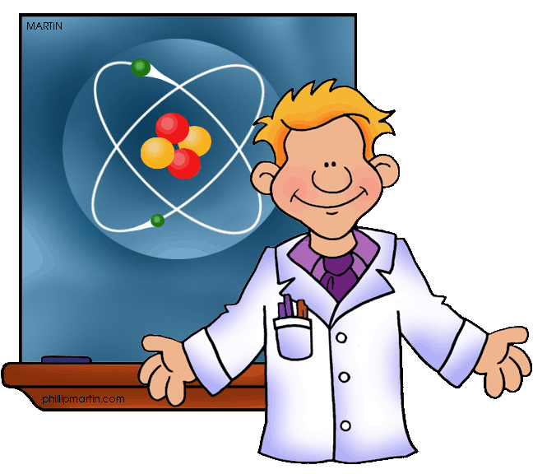

**TUTORIAL**

**Force, Motion & Energy**

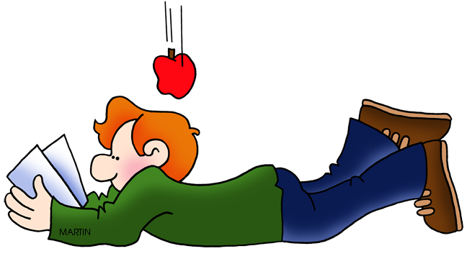

**TUTORIAL**

**Earth & Space**

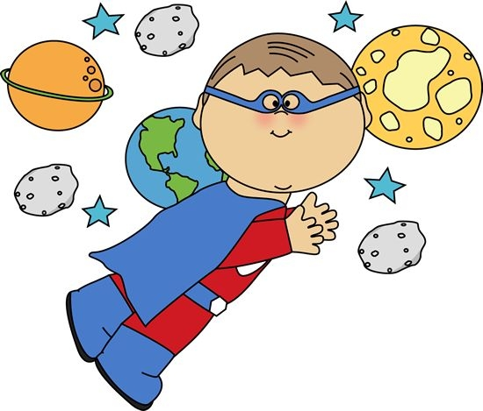

**TUTORIAL**

**Organisms & Environments**

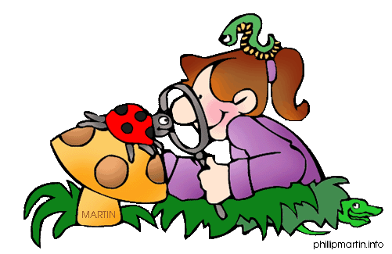

**TUTORIAL**